

**Weekly Lab Student Report**

Week 2 Lab

Lab Title: Create Firewall Rules

Student Name: Roman Kovtun

Date: 11/10/2018

**Lab Diagram**



Paste your screenshots under the appropriate topic below.

1. Take a screenshot of the Firewall Setting in Task 1 Step 8. (5 points)

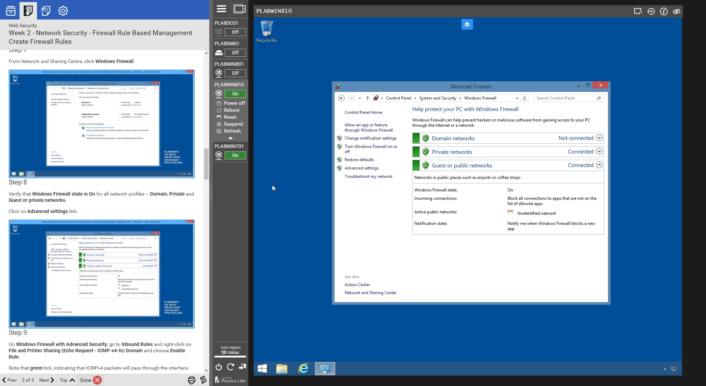

1. Take a screenshot showing the result of the ping in Task 1 Step 11. (15 points)

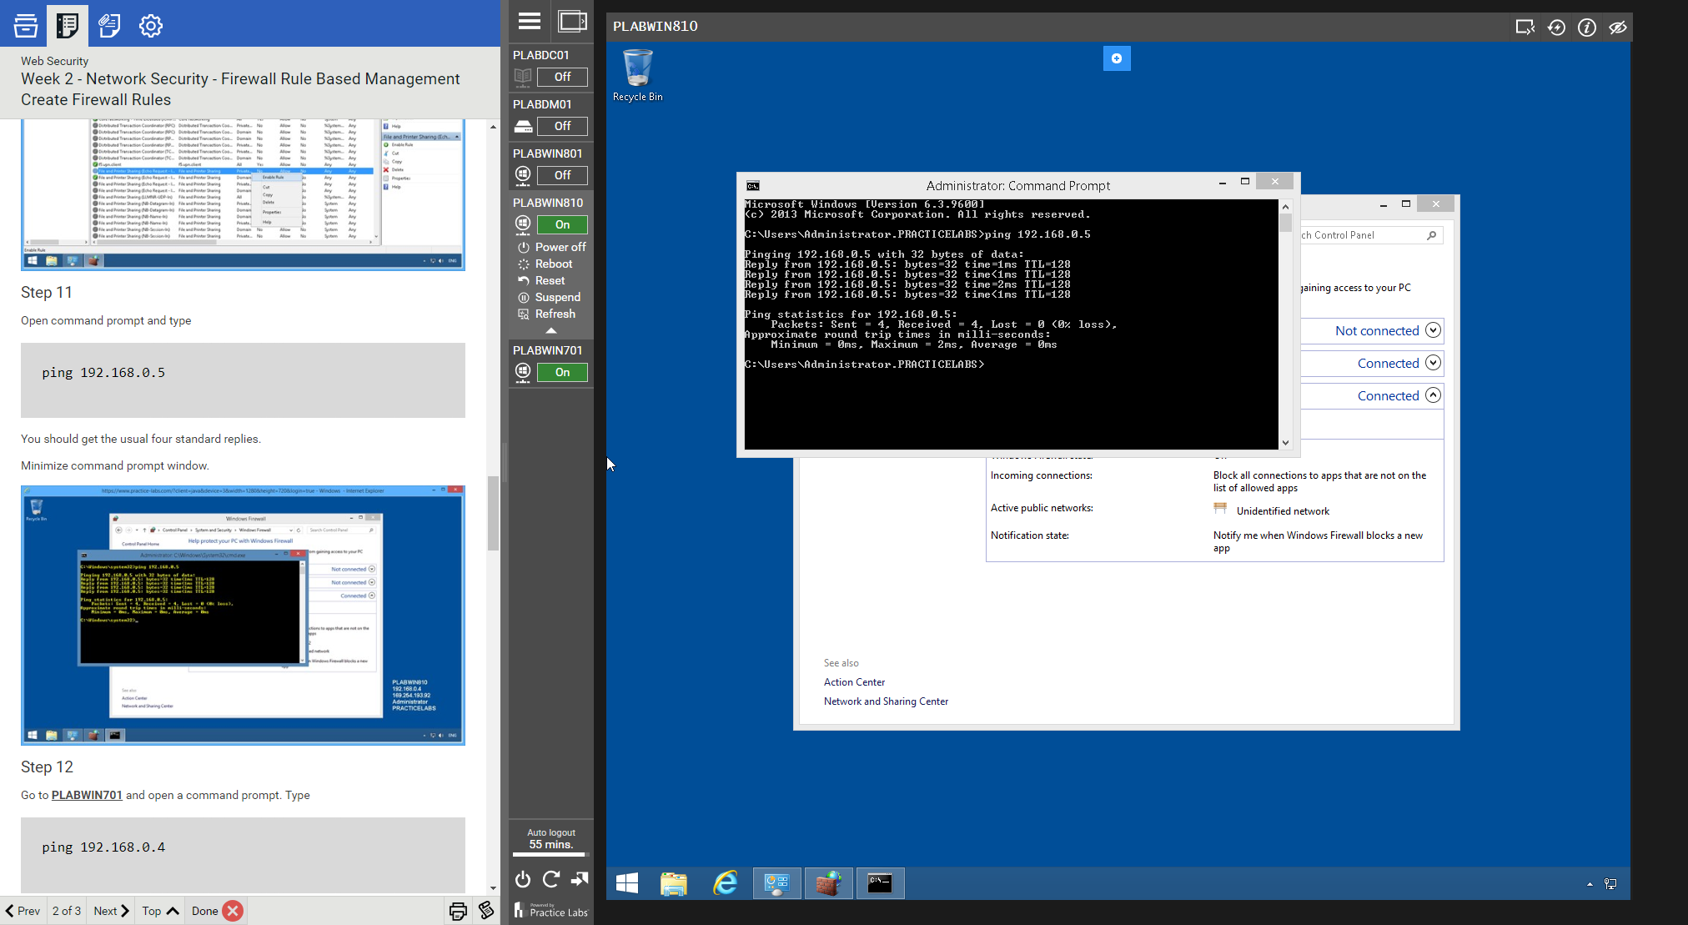

1. Take a screenshot showing the result of the ping in Task 2 Step 5. (15 points)

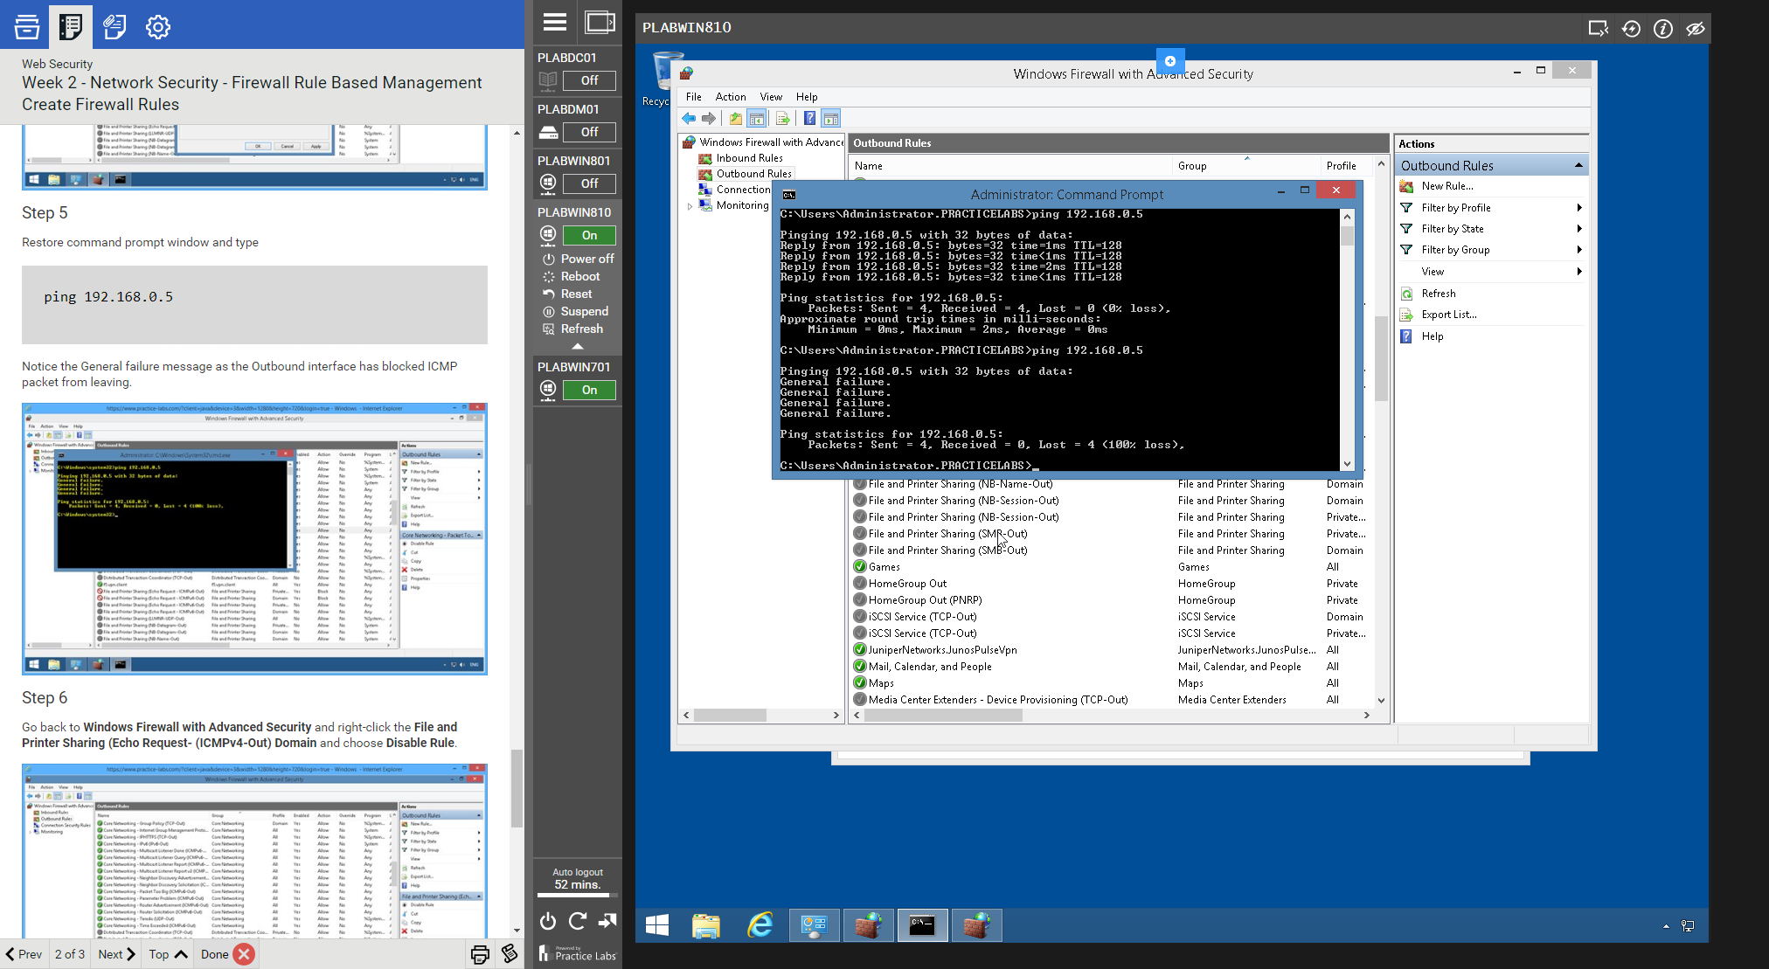

1. Take a screenshot showing the result of the ping in Task 2 Step 8. (15 points)

